Tab 1




https://photos.app.goo.gl/hJgpRA8vegKyG1Ab6

Zara’s email:
pereiraz2027@gmail.com

Mumbai, India

A passionate musician, educator, and mental health advocate bridging the worlds of music for wellness, performance, and creative education. Dedicated to exploring how music transforms minds, heals communities, and inspires the next generation of artists. Zara’s research and musical instincts are founded in her research in the field of psychology and instruction she has learned from The Nordoff-Robbins music therapy techniques (she is not a qualified music therapist).

Schools and Sessions

Work Experience with Music Therapist, Sarah D’Souza
August 2024-April 2025
Observing and assisting expert Music Therapist in her private sessions

The Music Circle, September 2025
Under the supervision of Priyanka Pandit
Leading some Music Connect activities and observing an expert practiioner

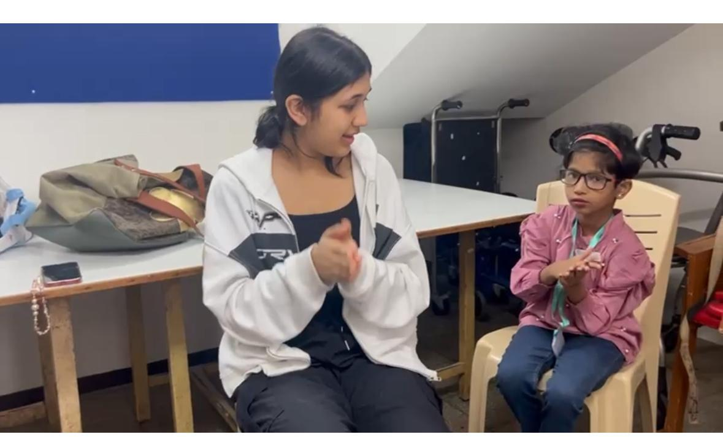

August 2025 to present
Music Connect: Launch of the Curriculum in Share the Music CSR, American School of Bombay
Leading Music for Wellness Activities for the children of Happy Feet HOME

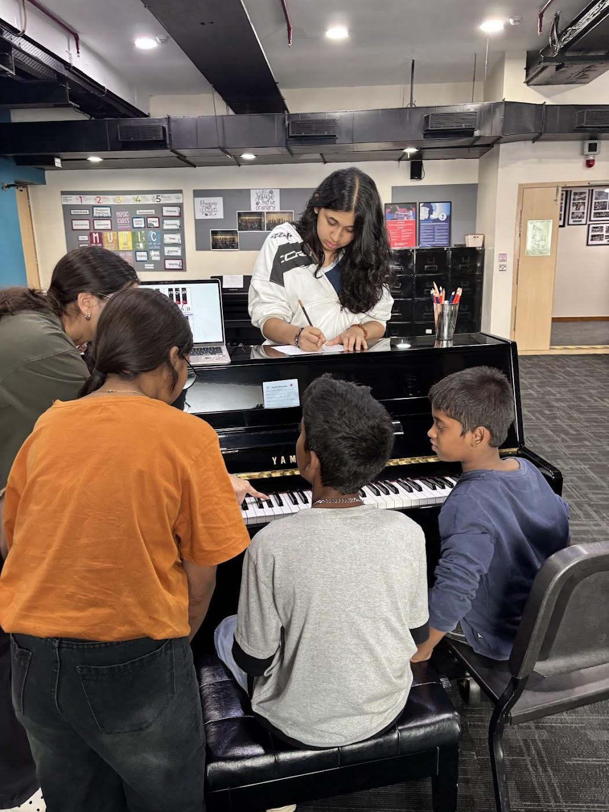

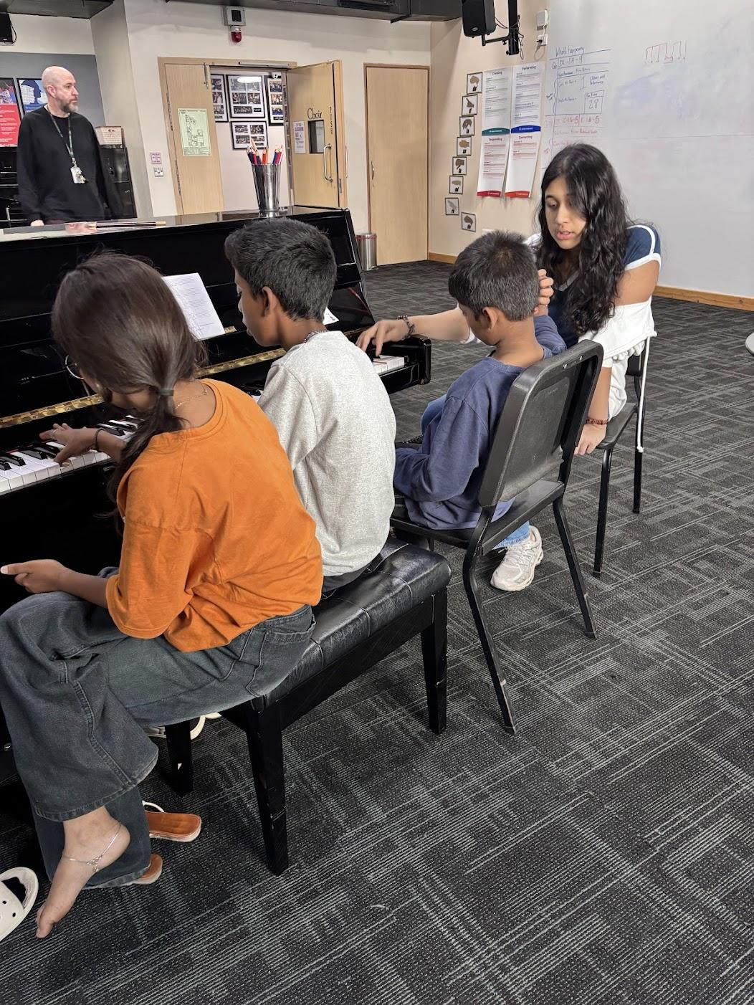

Day Visit to Happy Feet Home
October 2025

This visit to the Happy Feet Home was instrumental in Zara learning more about the lived experiences of the students she worked with. She learned about the care, struggles and extensive support the children of this NGO receive. The need to use music as a tool to escape, uplift and connect people became even more relevant.

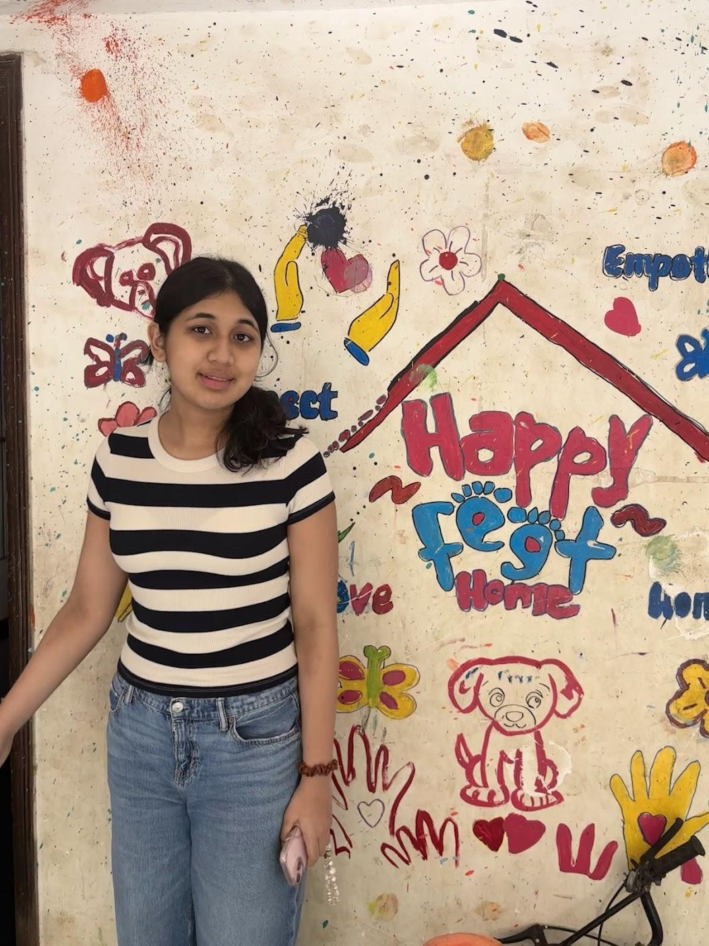

January 2026, Teacher Training Academy at The American School of Bombay
The first student to ever lead a session for teachers from The State of Maharashtra
60 teachers came from around the region to learn skills from technical experts.
Each unit of the The Music Connect curriculum was taught and experienced by teachers and it now reaches multiple schools across the region.

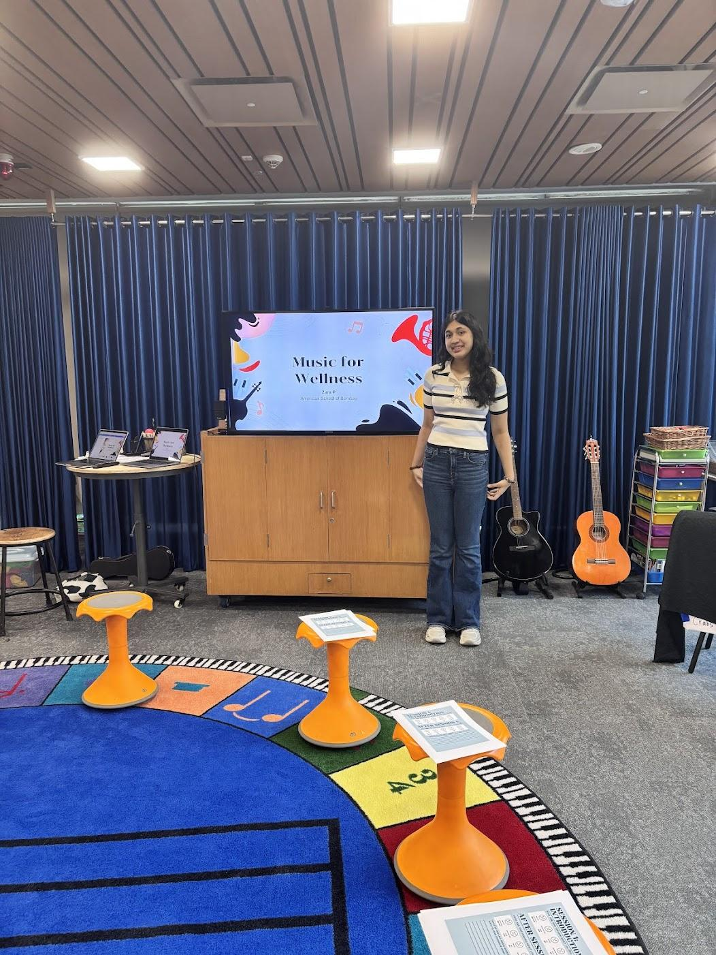
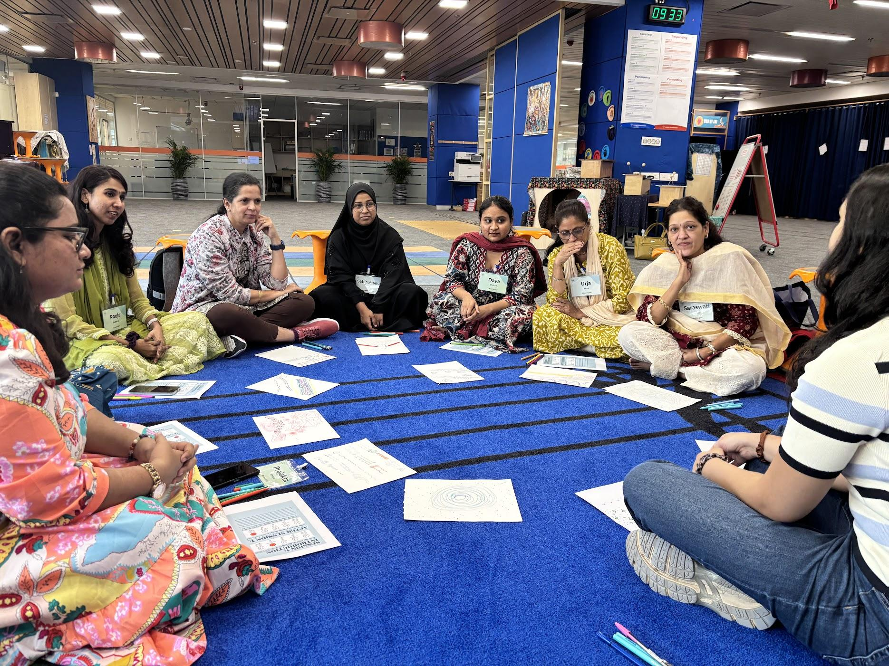

Insert link: AF1QipP9NZbJaJ7EKDWxoQQGreyY29uDh3Ubk6kONKqr

Akanskha School, NGO, Mumbai, November 2025 to present

It was here that Zara found herself as a leader, a mentor and a friend to the young students of this progressive school. The connections made and the experience of sharing musical skills together left an indelible impact. Zara will continue to work with this school during the school year 2026/7.

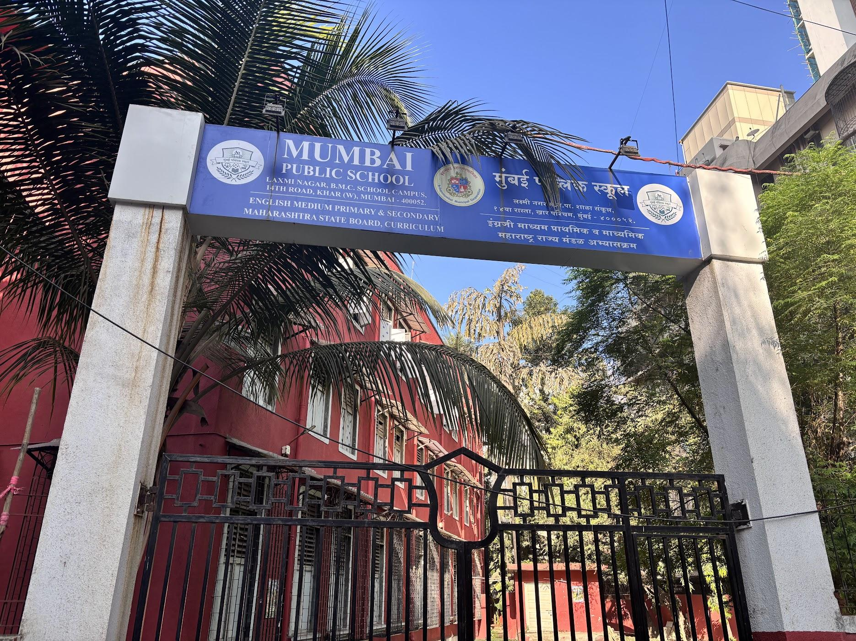

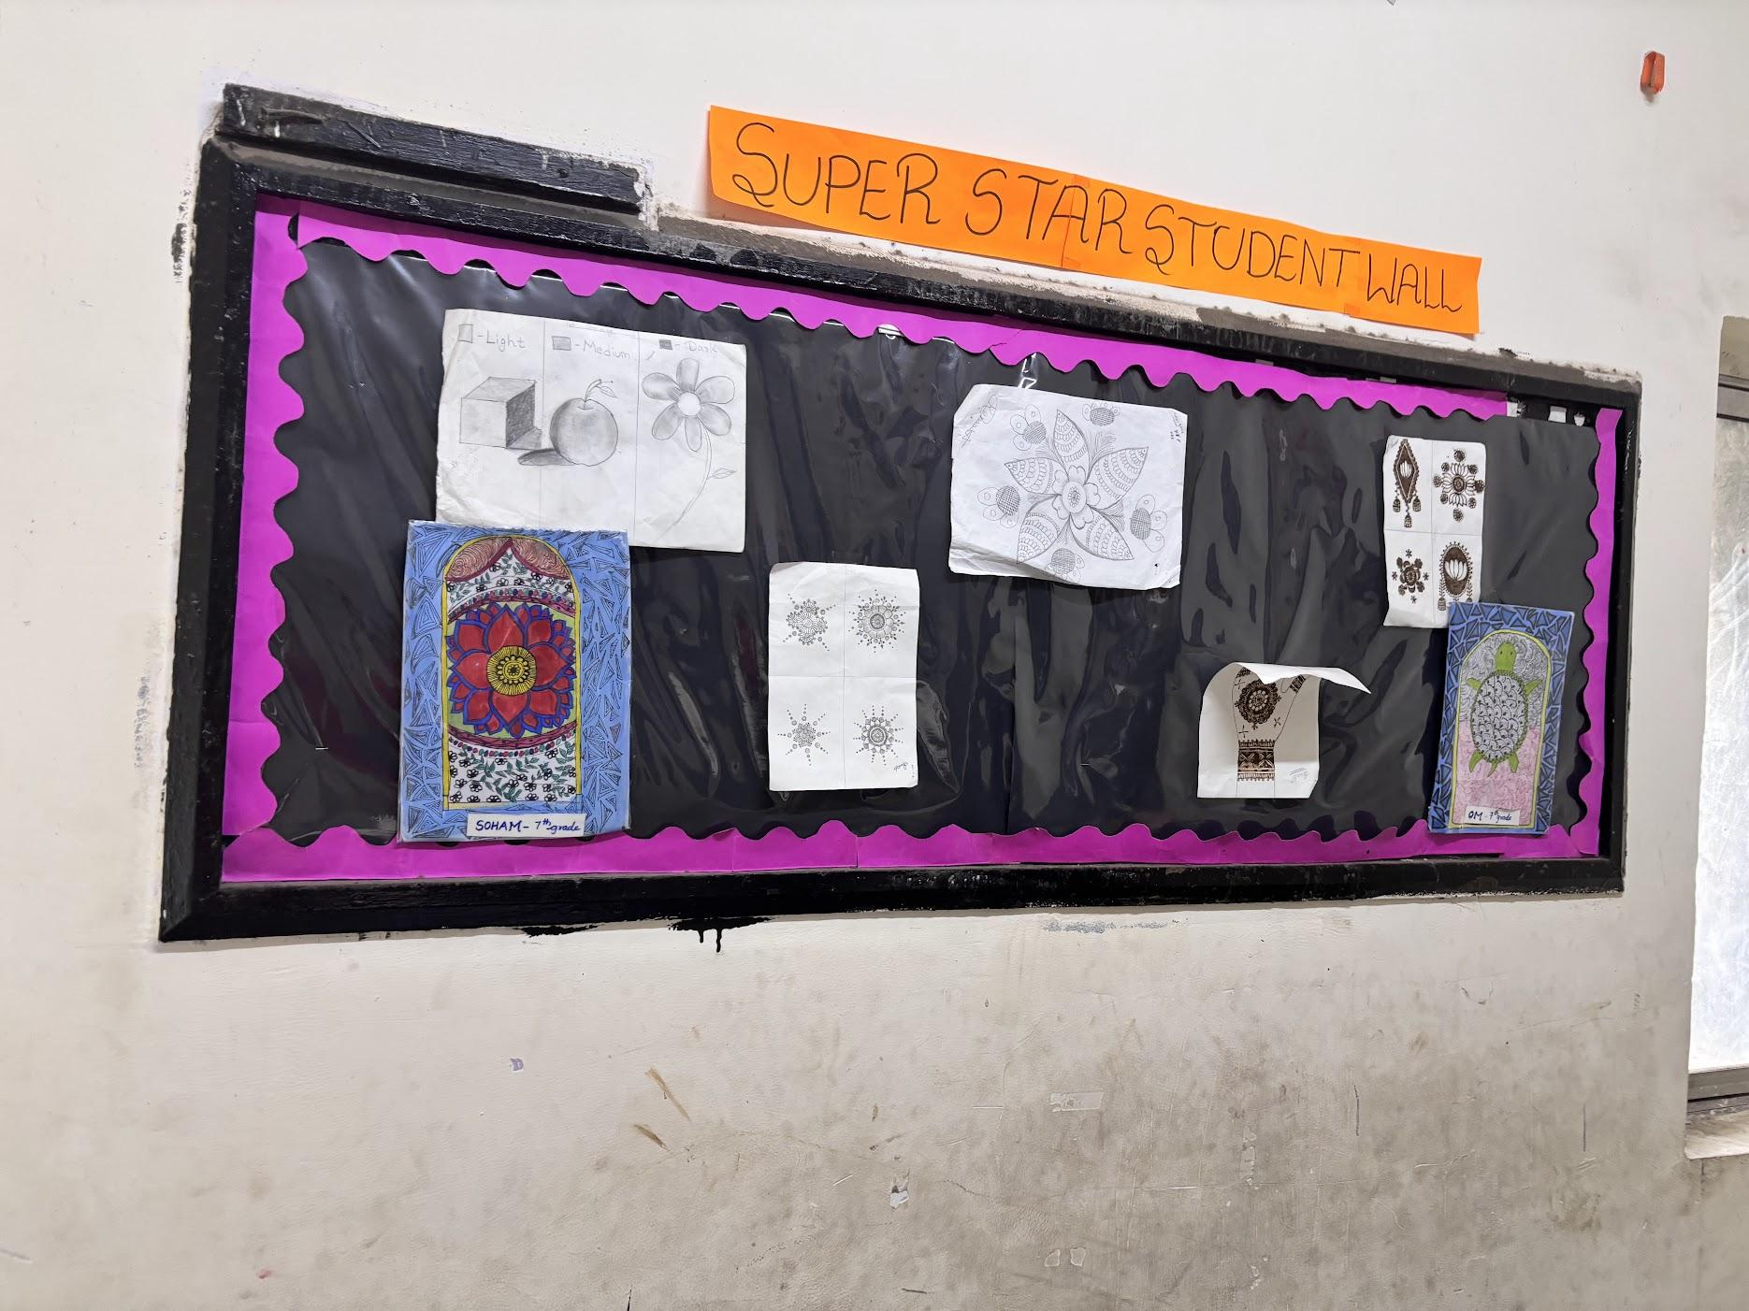
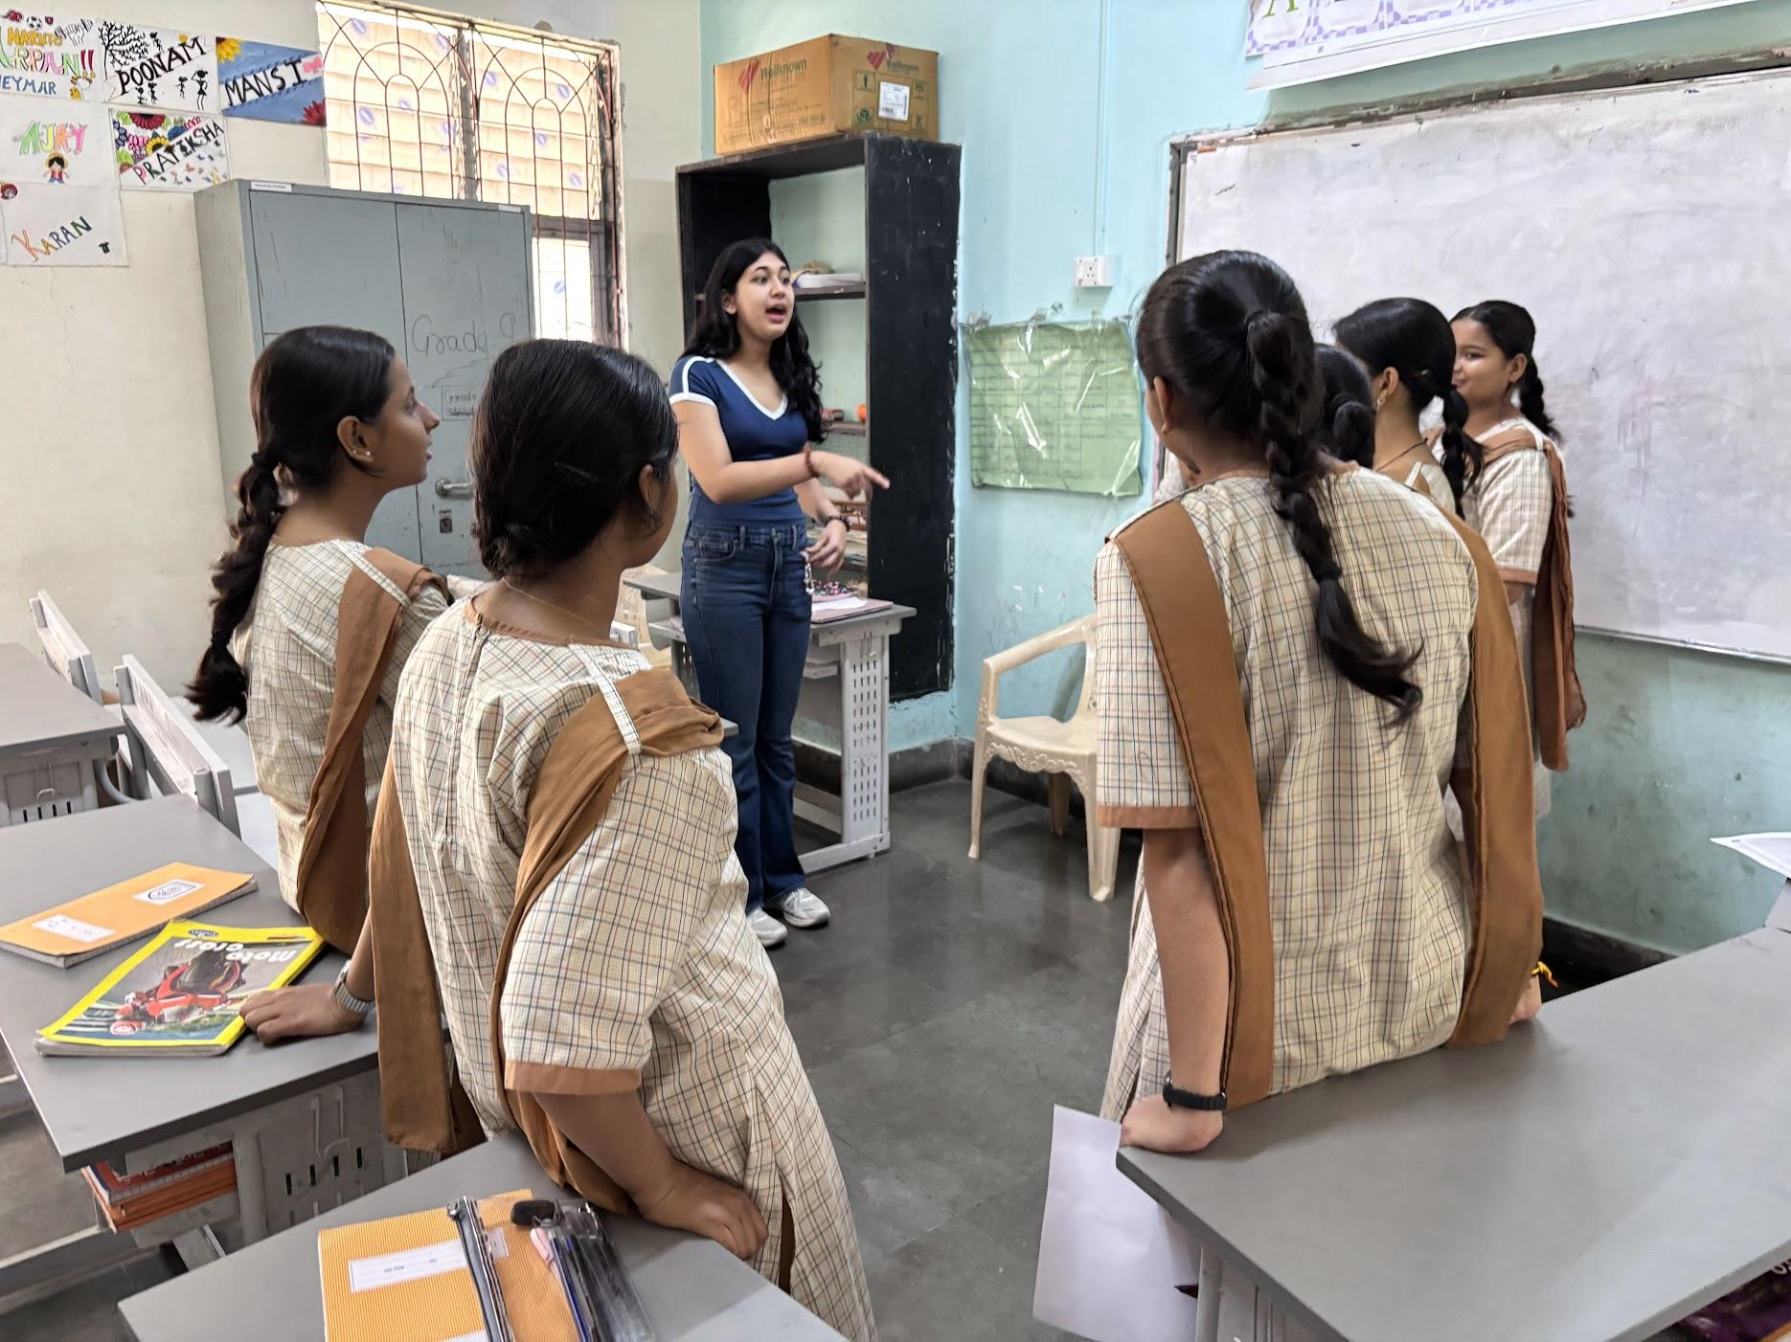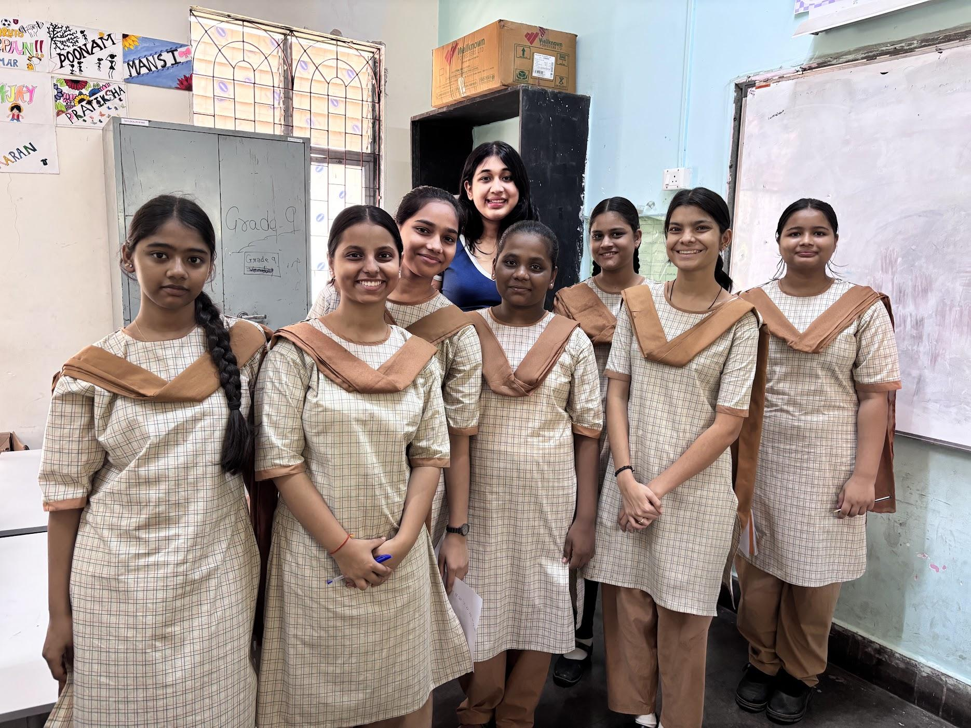

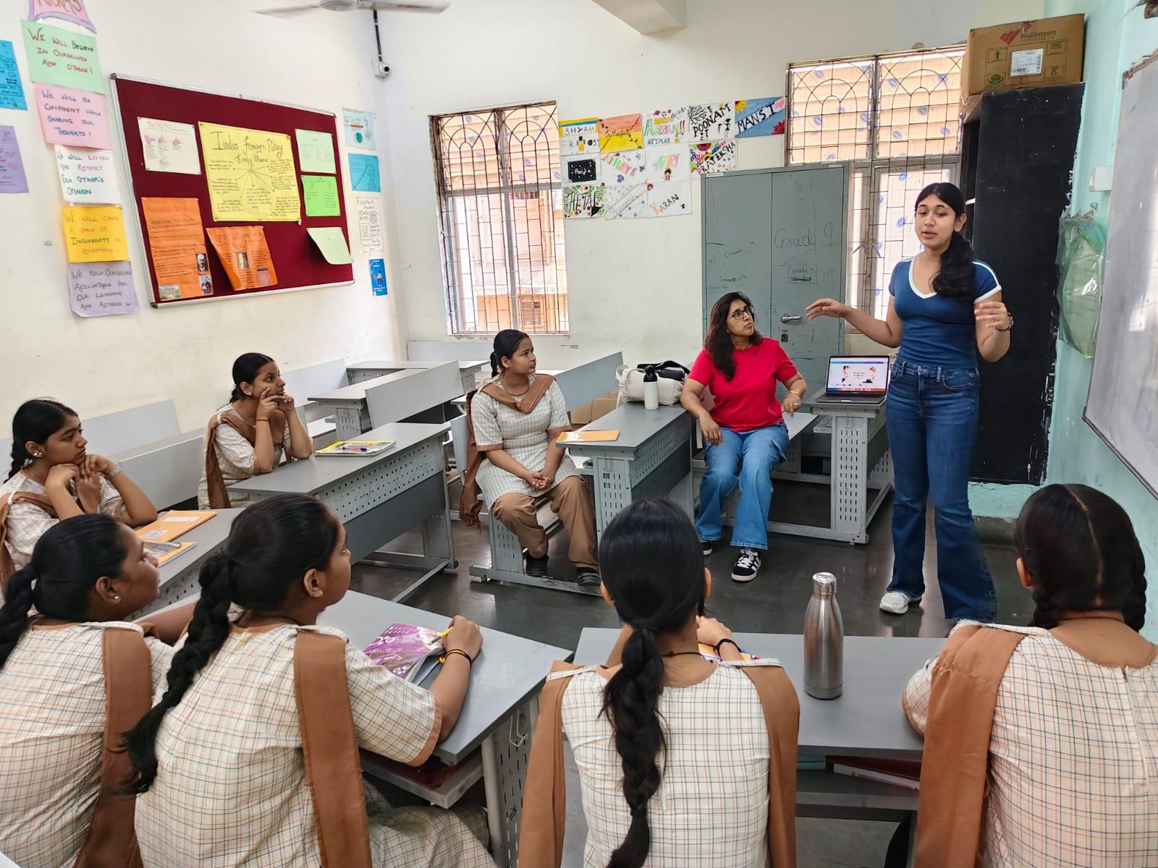

Working with students on the Music for Wellness Curriculum
Voice coach for The Sound of Music production

It was here that Zara found herself as a leader, a mentor and a friend to the young students of this progressive school. The connections made and the experience of sharing musical skills together left an indelible impact. Zara will continue to work with this school during the school year 2026/7.

https://photos.app.goo.gl/oCZssnrZMMqXndLD7

Aseema School, NGO, Mumbai, January 2025 to April 2026

Solve Day, Session Leader at The American School of Bombay
Zara adapted her curriculum for students from Grade 6 to 12 at her school in order to introduce music as a form of healing, to relieve anxiety and provide a means of escapism. Students participated willingly in the activities and collectively made a shared playlist to meet different emotional needs.

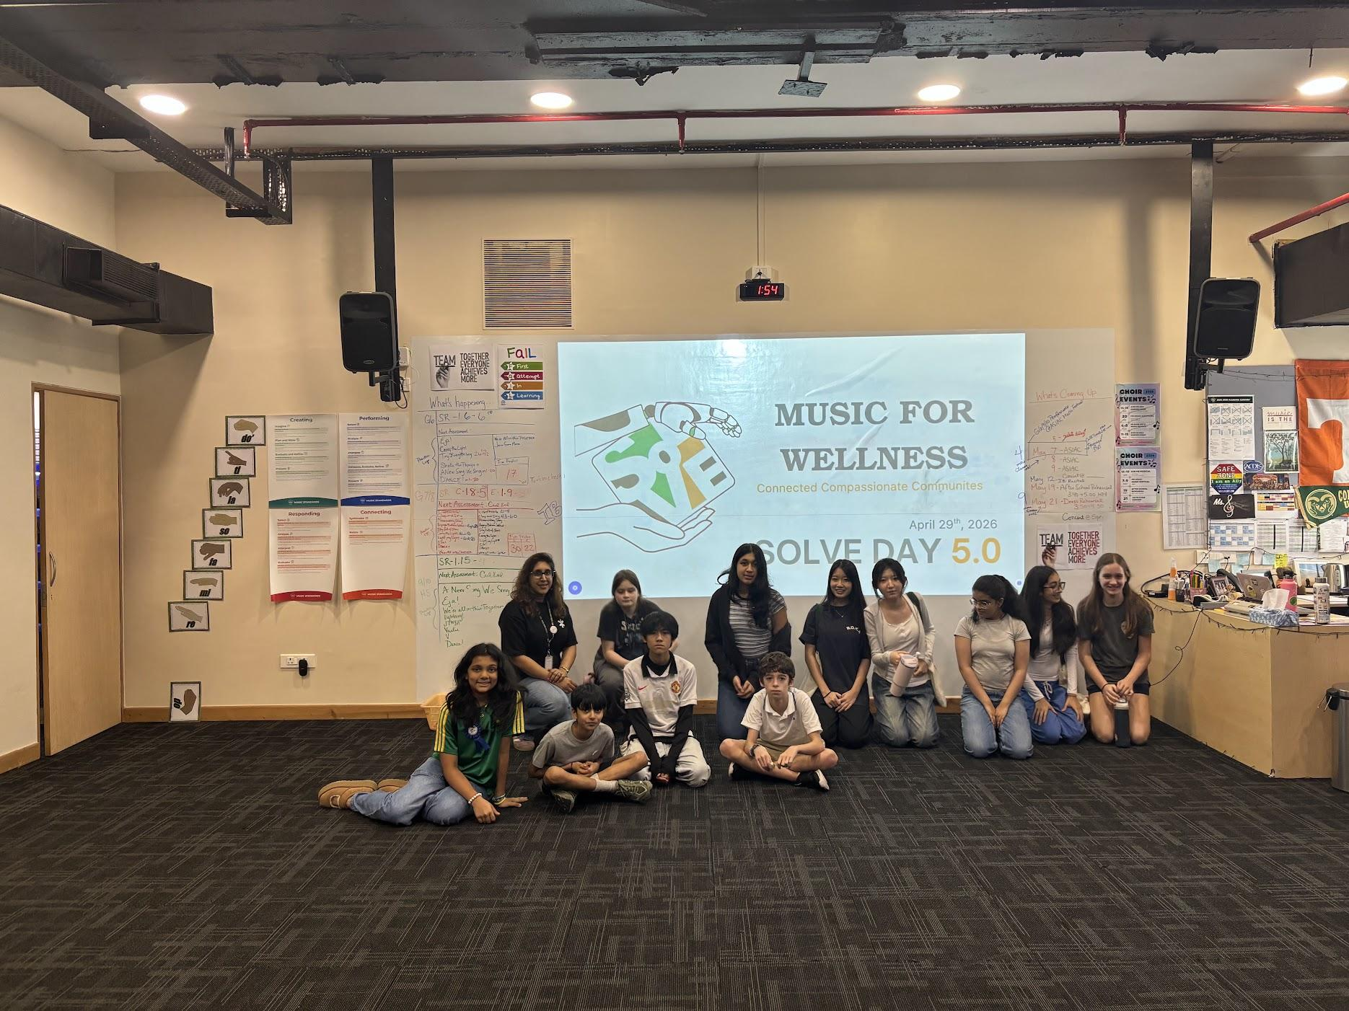

Please embed

AF1QipNrReqTrbhCw85d1yrKKaLoHBBMY0-ZC0Rq5EZg

AF1QipMR4GdRU5CIfpnNNfIZjWejJfs85ITXfHNlONEA

St Anthony’ Home for the Aged
November 2025-present

Zara visits the residents from this home for the aged and conducts regular sing-a-long sessions based on shared songs, requests and hymns. Many residents have requested their favourite songs and enjoy their time with Zara. This has been a rewarding experience, as there are many residents who come to life during these moments. Some non-communicative residents tap along, sway and smile to the beat and melodies of these songs.

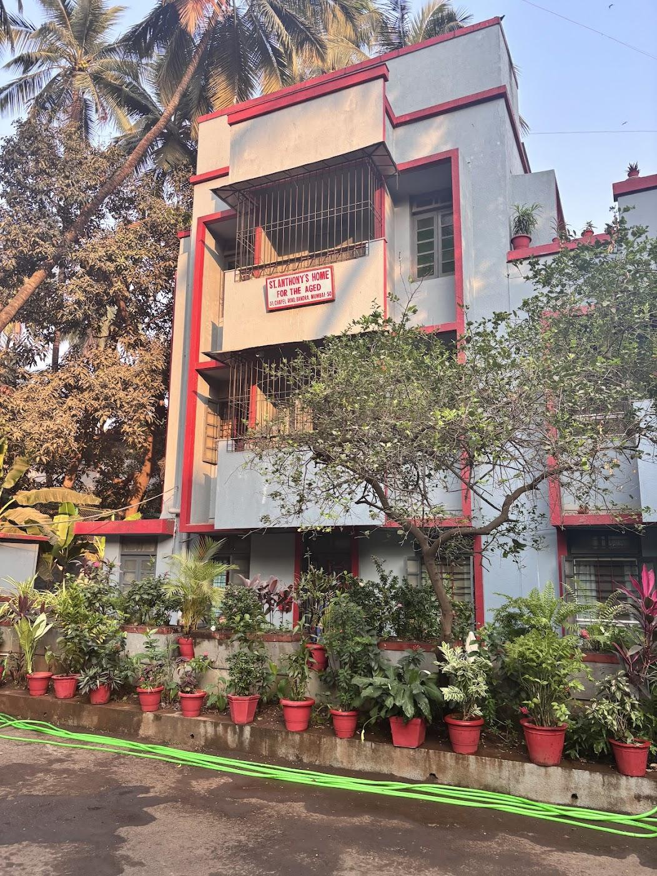

Insert links

AF1QipOsniF-obU-SQQokBAnZ89aAsS06A3Cg1us9H_H

AF1QipPzGWFnwuNyMYj5VYwtvKogAChwMMH_P6pu10lf

Youtube Link:
https://www.youtube.com/@ZaraPereira-k3b

Her photography:

Photography57 items · SharedMore options

Botanicals:
https://photos.app.goo.gl/zcyrGj6CiSX62qot5

Her art work:

Her music playlist

Her articles:
https://drive.google.com/file/d/1-FU0EU3WJXaa4hP8Y6sMFch2SwCQ1zIs/view?usp=sharing

Young Minds blog: https://www.youngminds.org.uk/young-person/blog/the-double-edged-sword-of-add/

Photos of her wellness curriculum:
Music connect
https://photos.app.goo.gl/hJgpRA8vegKyG1Ab6

https://drive.google.com/drive/folders/1nVTGhdXdVkyRNyGSSYFRnXPiLHsGhXc3?usp=share_link

References:

https://docs.google.com/document/d/1h2FrVo8qG8-CLaK6KNDVHa79EEfySHV2/edit?usp=sharing&ouid=102858551705727703469&rtpof=true&sd=true

AMIS CHOIR

Tab 2

Music Connect

First page:

Please change wording to:

A passionate musician, educator, and mental health advocate bridging the worlds of music for wellness, performance, and creative education. Dedicated to exploring how music transforms minds, heals communities, and inspires across disciplines and identities. Zara's research and musical instincts are founded in her research in the field of psychology and musical theory.

Music Connect:
Music Connect is Zara's original music-for-wellness curriculum, designed to promote emotional wellbeing, connection, and self-expression through evidence-informed musical experiences. Its foundations are grounded in psychological theory and research, drawing on findings from neuroscience, developmental psychology, and the wider body of research on music and wellbeing. To deepen her understanding of the field, Zara has undertaken specialist training with the Nordoff-Robbins Centre for Music Therapy, completed online coursework through the Berklee College of Music, and observed experienced practitioners working in clinical settings.
Music Connect has been implemented with students and educators across India, the United Kingdom, and the United States, where Zara has delivered workshops and trained teachers to use music as a practical tool for supporting wellbeing in educational settings.
The curriculum uses engaging, interactive musical experiences to build connection and support longer-term developmental outcomes. Activities are designed to strengthen communication, emotional expression, social connection, resilience, self-regulation, creativity, and confidence, while encouraging cognitive engagement and collaboration. Rather than providing clinical intervention, Music Connect translates evidence-informed principles from psychology and music-based practice into an accessible educational programme that empowers schools and communities to use music to support wellbeing.

*Zara does not claim to be a music therapist.

Aseema School

Zara spent time engaging with students in the build up to and during their exam season. Students benefitted from being grounded in the present, moving their minds away from their studies and immersing themselves in the activities.

Here is some of the artwork created by students in response to a “draw what you hear activity”.

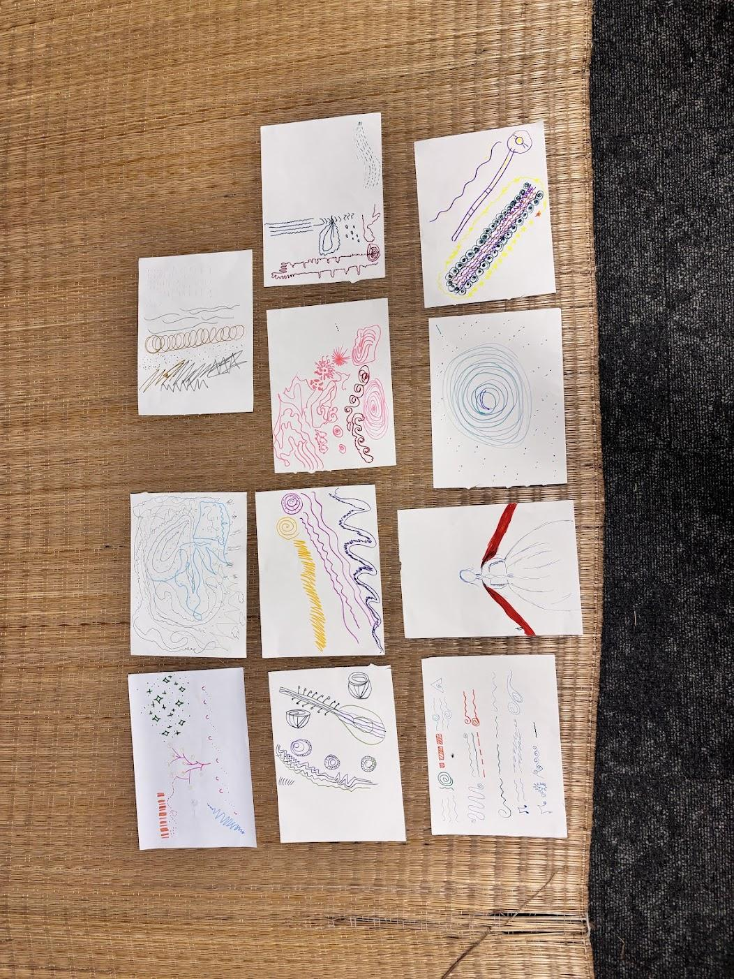

Solve Day:

There is the same video posted twice

St Anthony’s Home:

Same video posted twice

UK Chapter:

Zara took her learning and curriculum and adapted it to meet the needs of residents of Heavers Day Care Services which is part of the Alzheimer’s Society in South London.
She visited the centre during the month of June 2006 and was asked to return after a positive response in July.

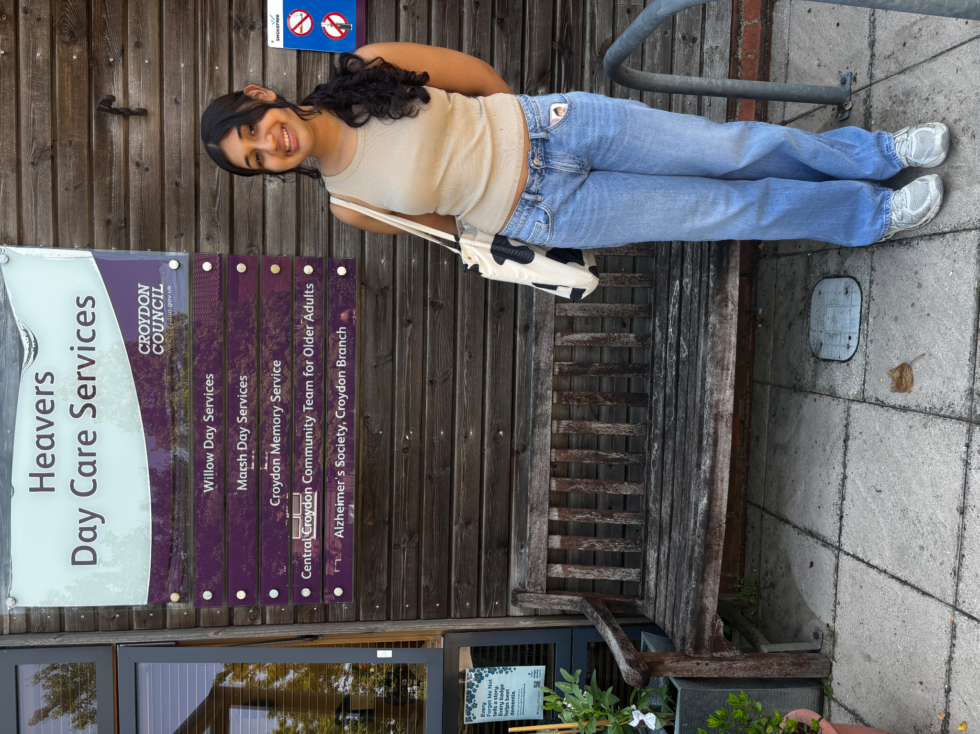

USA Chapter:

Zara’s curriculum was implemented and taught to the residents of Sage Eldercare, New Jersey, where Zara also underwent a two week internship with a trained music therapist.

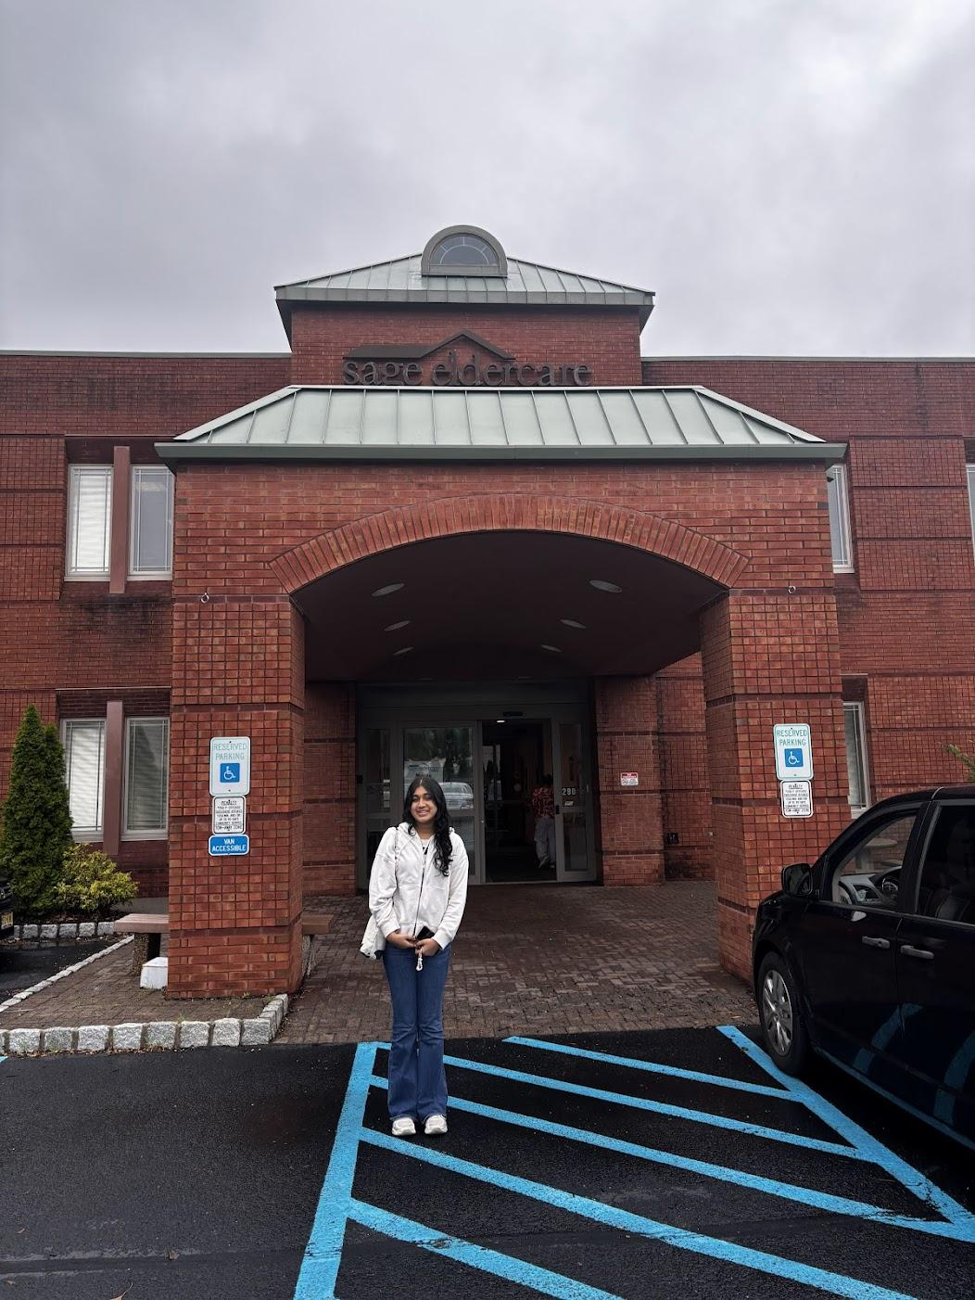

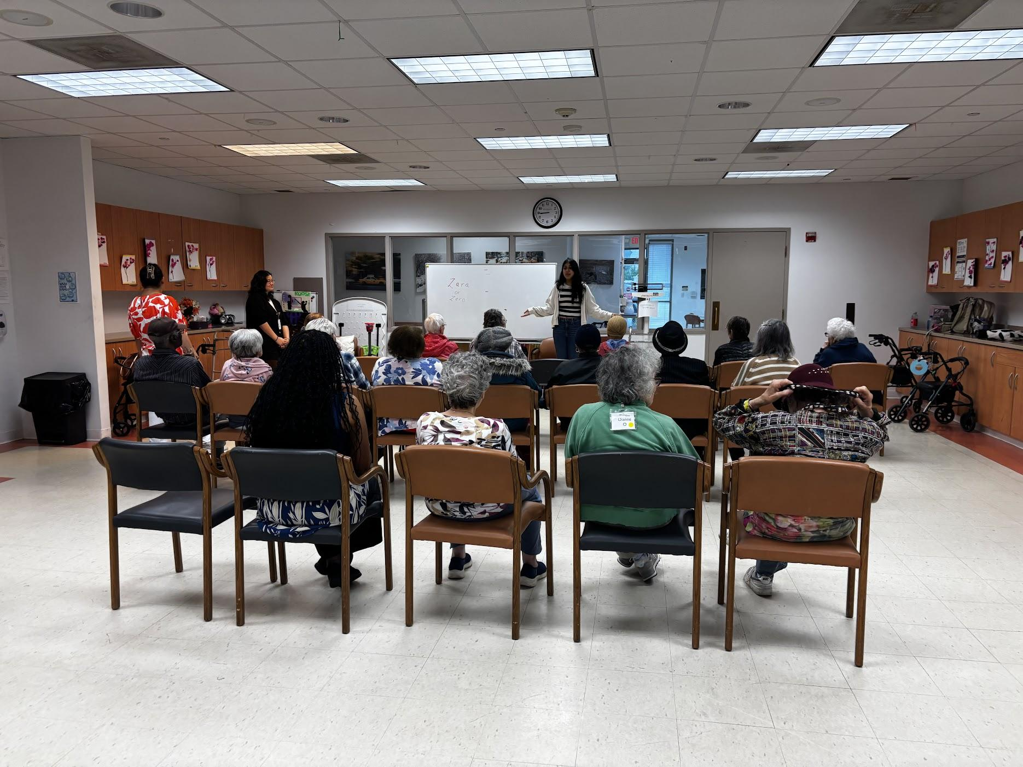

Please choose 2 videos from here of Dancing Queen and the last one.

https://photos.app.goo.gl/zTpqxbBuGHc7wMFq6

Music and the brain

Rituals and traditions starting from our first cry to lullabies, family songs and traditions are often unknowingly rooted in science. Music was sung to me from birth, with the Swahili love song Malaika written by Adam Salim greeting me in hospital by my Kenyan-born grandparents. Since that day, music has infused every step of my life and now the science of how it impacts us as humans has complemented this journey.

My published academic writing

Reading and research

Recommended reading

Organisations I follow or have interacted with

Tab 3
Ideas

https://www.gosh.nhs.uk/patients-and-families/support-services/music-therapy/case-studies/

The aim of music therapy is to create a fun, interactive musical connection and build on this to achieve longer-term goals. Goals can include helping a child or young person develop their coping skills, work on their communication, cognitive, or motor skills through music, or increase their ability to express how they’re feeling. We are trained to assess patients with a variety of medical conditions to support them in the following areas:
- Reaching and maintaining developmental milestones.
- Rehabilitation and recovery of cognitive, sensorimotor, and communication deficits due to neurologic injury or disease.
- Emotional processing and expression.
- Coping with stress and anxiety surrounding diagnosis and medical treatment.
- Pain management and relaxation techniques.
- Psychological wellbeing related to short- and long-term effects of medical diagnosis and hospital admission.
- Maintaining a sense of ‘normal’ life, and creating positive, shared experiences for the whole family.
- Boosting engagement with other therapies.

